|  |  |  |
| --- | --- | --- |
| **Islamic University**  **Faculty of Engineering**  **Department of Mechanical Engineering** |  | **الجامعة الإسلامية**  **كليه الهندسة**  **قسم الهندسة الميكانيكية** |

**ME 3522 – THEORY OF MACHINES**

**Term 461 – Fall 2024**

**PROJECT – PART- 3**

**Project Title: Rack and Pinion Mechanism In Steering Wheel System**

**Student Name: Naufal Sutendar ID # :411020253**

**Student Name: Tamim Sindi ID # :431010183**

**Student Name: Yusuf Razok ID # :411011823**

|  |  |  |  |
| --- | --- | --- | --- |
| **Contents** | **Max Marks** | **Allocated Marks** | **Comments** |
| Title Page | 5 |  |  |
| Length of Final Project Report (Min. 8 pages) | 5 |  |  |
| Formatting Rules | 5 |  |  |
| Grammar and Sentence Structure | 5 |  |  |
| Table of Contents | 5 |  |  |
| Project Abstract | 5 |  |  |
| Introduction | 5 |  |  |
| Literature Review | 5 |  |  |
| Design Specification | -- |  |  |
| Design Calculations | 10 |  |  |
| Drawings with dimensions | 10 |  |  |
| Method of Solution / Manufacturability | 15 |  |  |
| Summary and Conclusions | 5 |  |  |
| Budget for Overall Product Cost | 5 |  |  |
| Schedule/Gantt Chart | 5 |  |  |
| References | 5 |  |  |
| Detail role of Each Team Member | 5 |  |  |
| **Total** | **100** |  |  |

|  |  |
| --- | --- |
| **Coordinator: Dr Sohaib Zia Khan**  **Signature:** |  |

**Table of Contents**

**Chapter 1 :** **Introduction 4**

**Chapter 2 :** **Literature Review 6**

**Chapter 3 :** **Rack and Pinion Mechanism in Steering Wheel System 8**

**Chapter 4 :** **Design Specifications 13**

**Chapter 5 :** **Manufacturability 15**

**Chapter 6 :** **Conclusion 20**

**References 21**

**Schedule /Gantt Chart of project 22**

**Detail role of Each Team Member 23**

**Abstract**

This project investigates the design, material optimization, and performance analysis of a rack and pinion steering system, with an emphasis on efficient control and cost-effective production. Building on prior research, the current phase leverages additive manufacturing, specifically FDM 3D printing with PLA, to prototype steering components. The main focus is to assess the structural integrity, durability, and feasibility of using PLA as a primary material in automotive steering systems.

The project utilizes Fusion 360 for designing and simulating the rack and pinion mechanism, focusing on factors such as strength, deformation, and wear resistance. Simulation analysis allows a detailed understanding of PLA's limitations and strengths in a high-stress automotive environment, while physical prototyping provides real-world insights into alignment, material tolerances, and manufacturability constraints. Results from simulations and experimental testing on 3D-printed prototypes contribute to refining design specifications and identifying potential improvements, particularly in material choice and geometry.

Through detailed optimization of gear teeth geometry and careful selection of PLA formulations, this project has successfully enhanced the load-bearing capacity and heat resistance of the rack and pinion steering mechanism. This approach confirms the viability of using sustainable, low-cost materials for engineering applications traditionally dominated by metals. The project demonstrates that PLA, when optimized and properly configured, offers a lightweight, efficient, and responsive solution for steering systems, with potential adaptability for various applications beyond automotive settings.

**Keywords:** analysis, 3D printing, design, PLA, rack and pinion

# **Chapter 1 :Introduction**

The rack and pinion mechanism is a core technology in automotive steering systems, valued for its simplicity, responsiveness, and ability to translate rotational motion into precise linear movement. At its core, the system comprises a rack (a toothed linear component) and a pinion (a gear that engages with the rack), which work together to steer the wheels of a vehicle as the driver turns the steering wheel. This direct and efficient control system is widely used in modern vehicles and has extended applications in industrial machinery, robotics, and mechanical actuators. Rack and pinion systems are also integral in vertical lifting, horizontal positioning, and precision equipment control, showcasing their versatility across fields. ( *figure 1)*

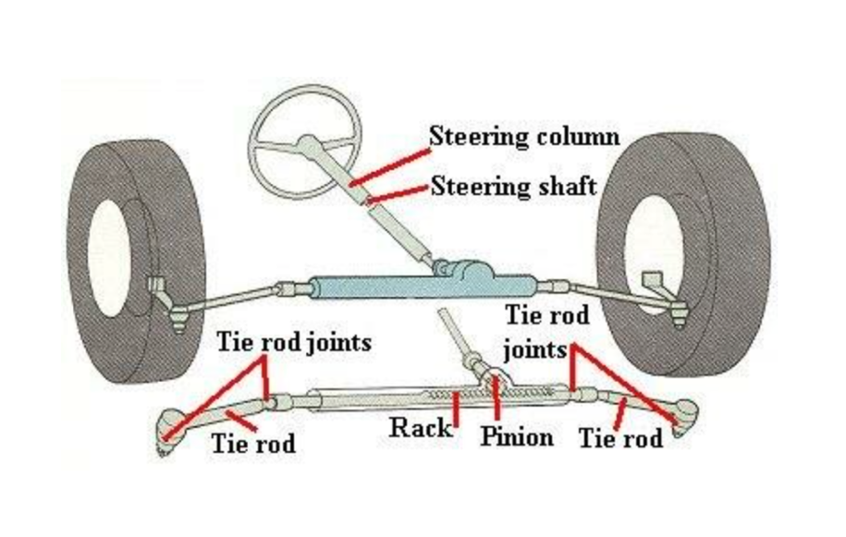

Figure 1. Rack and pinion linkages and its configuration. Source : ever-power.net

This project investigates the design, material selection, and manufacturability of a rack and pinion steering system, emphasizing the use of additive manufacturing technologies and sustainable materials. While traditional steering systems are typically manufactured from structural steel, this project aims to prototype and test the system using Polylactic Acid (PLA), a biodegradable and cost-effective thermoplastic compatible with Fused Deposition Modeling (FDM) 3D printing. PLA’s ease of processing, along with its lower environmental impact, makes it a promising alternative for lightweight applications. However, its performance under high-stress and high-temperature conditions remains a challenge, particularly in automotive settings where durability and precision are critical.

Using Fusion 360, the rack and pinion assembly is modeled and analyzed to ensure accurate alignment, load-bearing capacity, and minimal deformation under operational stresses. Simulation tools assist in identifying stress concentrations, optimizing component geometries, and adjusting parameters such as module, pressure angle, and tooth profile. The project will assess key performance metrics of PLA components, including wear resistance, frictional characteristics, and thermal stability, and will compare these against industry standards for steering applications.

The overarching objective of this study is to demonstrate that 3D-printed materials, specifically PLA, can meet the demands of a functional, reliable steering system. By exploring the boundaries of additive manufacturing and environmentally friendly materials in engineering applications, the project aims to provide insights into sustainable design practices while enhancing control system efficiency. Further investigation into alternative materials and advanced PLA formulations could potentially broaden the application range of such mechanisms, making them suitable for various engineering fields where cost, weight, and environmental impact are critical factors.

# **Chapter 2 : Literature Review**

The rack and pinion mechanism, widely used in steering systems, has been extensively studied due to its efficiency in converting rotational motion to linear motion with precision. This system’s effectiveness in steering control is attributed to its straightforward design and high responsiveness, making it an optimal choice for automotive and various industrial applications. The primary challenge in current research lies in optimizing material selection, design parameters, and manufacturing processes to enhance performance and sustainability. This review synthesizes the existing literature on material innovation, mechanical performance, and design optimization of rack and pinion mechanisms.

Chopane et al. (2017) [1] explored the use of Nylon 66 plastic gears within rack and pinion systems for Formula Supra cars, finding that plastic materials can significantly reduce weight, noise, and vibration compared to traditional steel components. Their research highlights the potential of polymer-based materials in improving the efficiency and comfort of steering systems by minimizing energy losses caused by friction and reducing overall system weight.

Rahmani Hanzaki et al. (2008) [3] focused on kinematic optimization of rack and pinion steering linkages, analyzing various design parameters and their impact on steering error and responsiveness. Their work demonstrated that precise adjustments in linkage geometry, such as tie rod length and pressure angle, can directly influence system accuracy, reducing steering lag and enhancing driver control. This insight is instrumental for this project, as optimizing these parameters can improve the control capabilities of a 3D-printed rack and pinion mechanism.

Additionally, Pereira dos Santos et al. (2011) [4] conducted a comparative analysis of finishing processes for pinion gears, specifically honing versus hard hobbing, which affect surface smoothness and engagement quality. Their findings indicated that honing results in a finer surface finish, reducing noise and facilitating smoother movement within the mechanism. This knowledge underscores the importance of manufacturing precision in rack and pinion systems, as surface finish quality directly impacts engagement efficiency, friction reduction, and operational lifespan [5].

Recent advancements in additive manufacturing have opened new possibilities for custom and sustainable material use. Researchers have explored Polylactic Acid (PLA) as a viable option for 3D-printed components in load-bearing applications, including rack and pinion mechanisms. While PLA’s mechanical properties are inherently lower than those of metals or reinforced polymers, studies show that it is a promising option for prototyping and lightweight applications due to its biodegradability, low cost, and ease of manufacturing at relatively low temperatures. According to various studies, PLA’s wear resistance and structural integrity can be enhanced by modifying its molecular structure or blending it with other polymers, making it a practical choice for applications where extreme durability is not critical.

Building on this prior work, this project aims to assess the feasibility of PLA in a rack and pinion steering system, with specific focus on load-bearing capacity, durability, and cost-effectiveness. By using 3D-printed prototypes, the study will evaluate PLA’s performance under stress and frictional conditions typical of automotive applications. Given the emerging interest in sustainable manufacturing, this research aligns with current trends in material science and additive manufacturing, seeking to bridge the gap between sustainable design and functional performance in engineering applications.

# **Chapter 3 : Rack and Pinion Mechanism in Steering Wheel System**

The rack and pinion mechanism as shown in the in this project functions by transforming rotational motion from the steering wheel into linear motion. The steering wheel is linked to the pinion (a spur gear) via a shaft, which is supported by a custom-designed holder. This holder minimizes surface contact with the shaft, reducing friction and ensuring smooth rotation. The mechanism will be manufactured using an FDM 3D printer with PLA+ material as shown in *figure 13*, selected for its durability and suitability in precise, functional prototyping. *Figure 2 below* explaining the parts in details. It has 13 components ; rack , pinion , shaft holder , rack holder , steering wheel , arm and tire representative ( 2 pieces mirrored ), connecting rod ( 2 pieces mirrored ), axle holder ( 2 pieces mirrored ), locking device ( 2 pieces ). All of the parts we designed and assembled in Fusion360 from Autodesk.

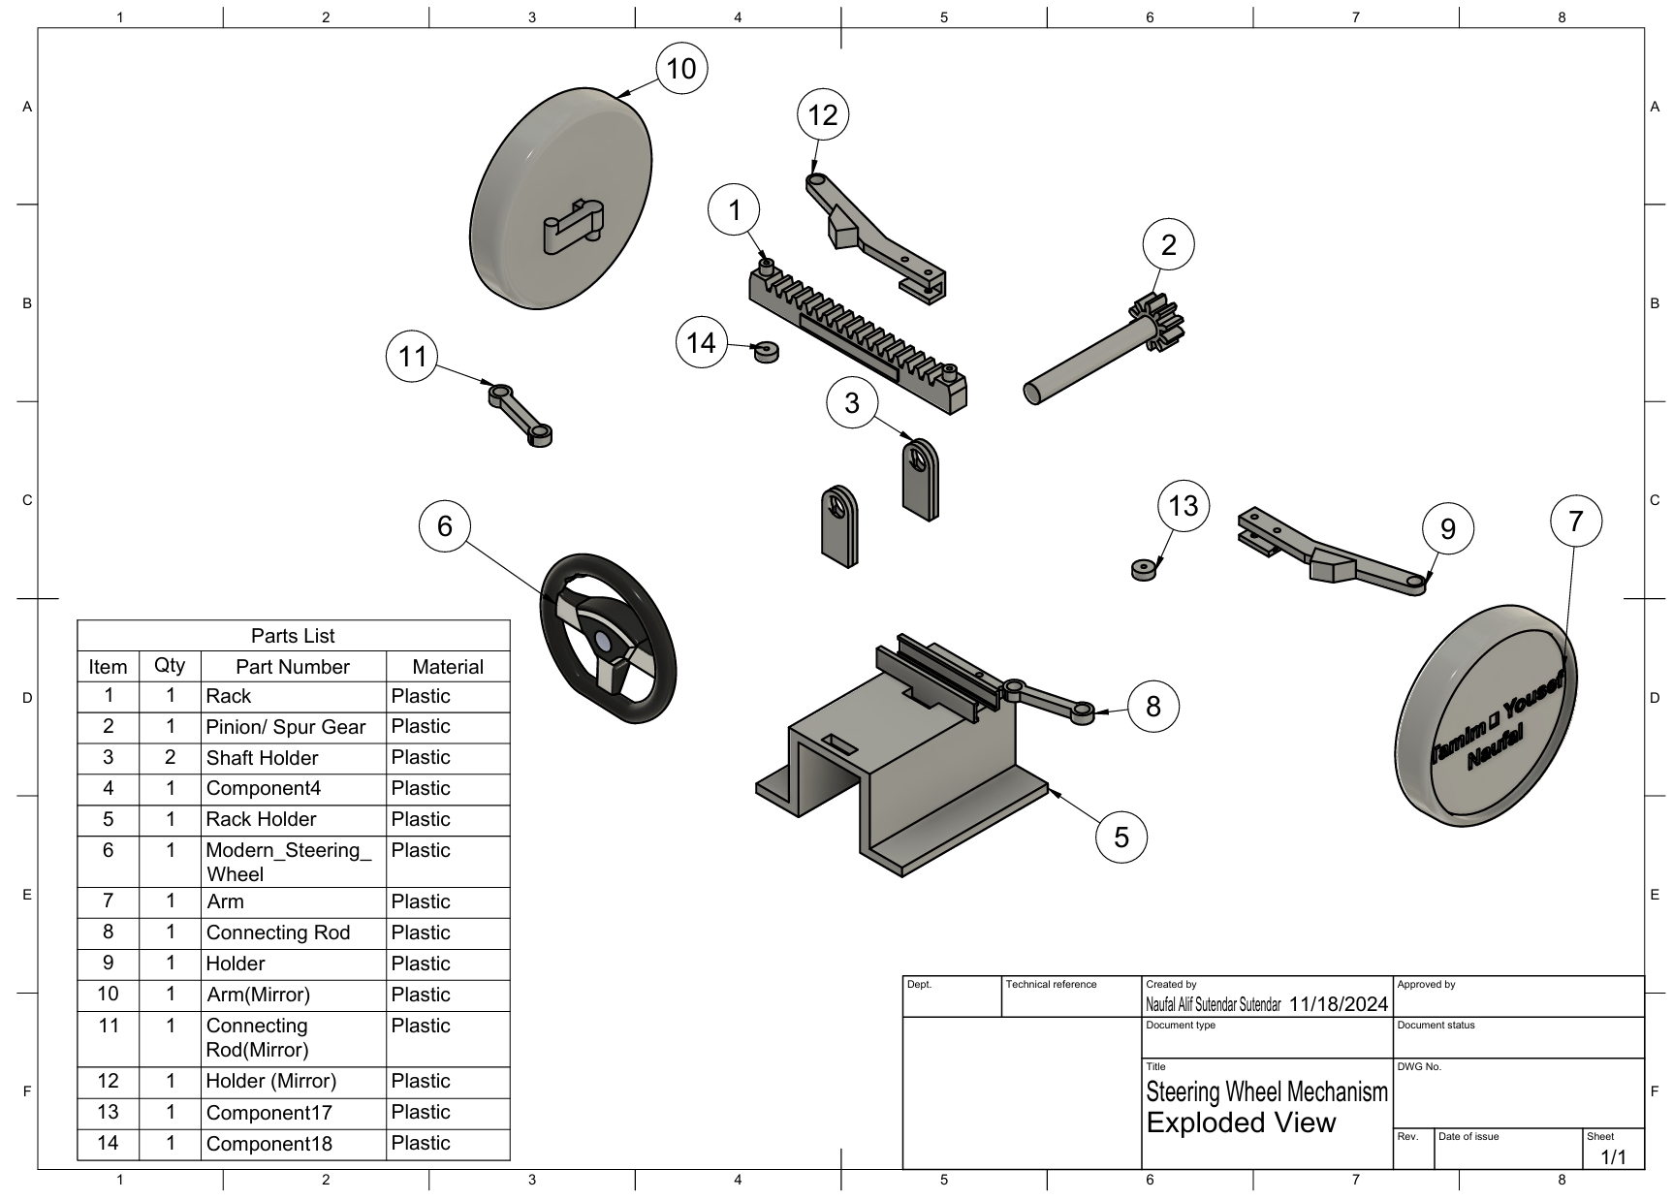

Figure 2 Exploded View

Since it will be manufactured using FDM printer, some special design features were added into shaft and rack holder. Special feature 1 is made to control the translation of rack which should be in only 1 axis ( X – axis/ Left - right ). Because this design does not use bearing at all then to reduce the friction between the shaft and holder as shown in *figure 3* below. These features absolutely reducing the manufacturing and provide more reliable method in prototyping.

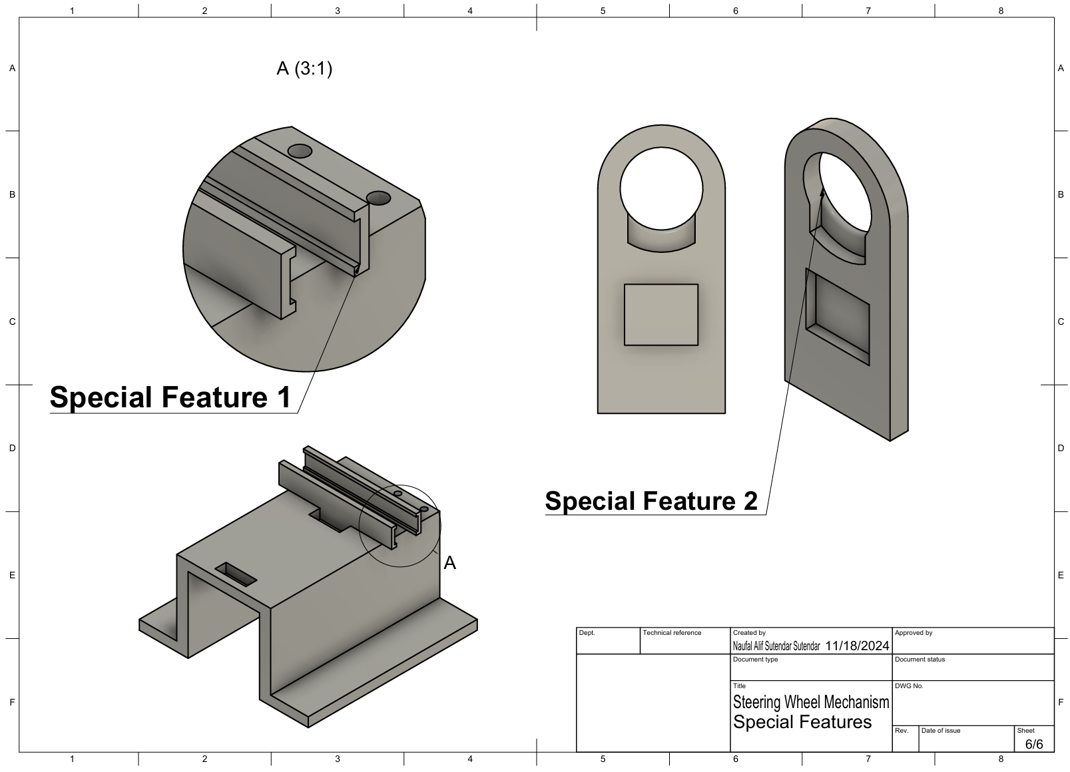

Figure 3 Special feature in shaft and rack holder

To optimize the efficiency of the rack and pinion mechanism, careful attention is given to both the alignment of components and the material properties of PLA+. PLA+ was chosen for its low friction and good wear resistance, qualities that enhance the smooth motion needed in steering applications. Additionally, the holder’s design minimizes friction by reducing surface contact with the shaft, which is particularly beneficial for maintaining consistent rotational motion. The choice of a fixed holder design enhances structural stability while allowing controlled movement of the rack, resulting in a precise and responsive steering system. The use of FDM 3D printing provides flexibility in creating complex geometries, allowing for easy prototyping and adjustment to further improve performance.

As the steering wheel rotates, the pinion (a spur gear) engages with the rack (linear gear), which mirrors the direction of movement. When the steering wheel is turned counterclockwise, the pinion drives the rack to move to the right, while a clockwise rotation causes the rack to shift to the left. This directional relationship allows for precise control over the linear motion of the rack, translating driver input smoothly into horizontal movement. The interaction between the rack and pinion is designed to maintain consistent contact and minimize backlash, ensuring accurate and responsive steering adjustments. This configuration is ideal for applications where precise directional control is essential, enhancing the reliability and feel of the steering mechanism. To be more specific in this project, rack and pinion are the main objective although it has another mechanism but it is still be manufactured to make the prototype as close as the real one.

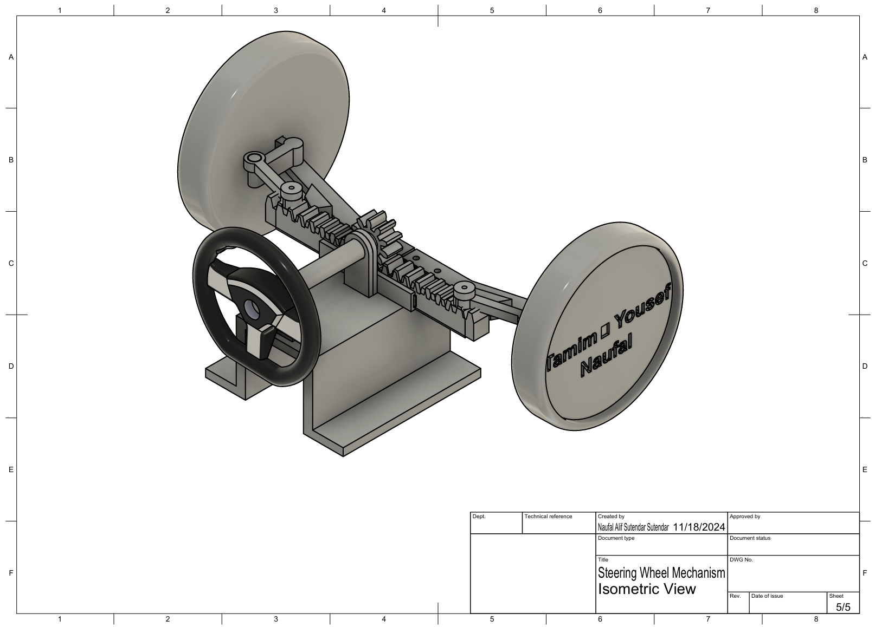

Figure 4 Isometric View

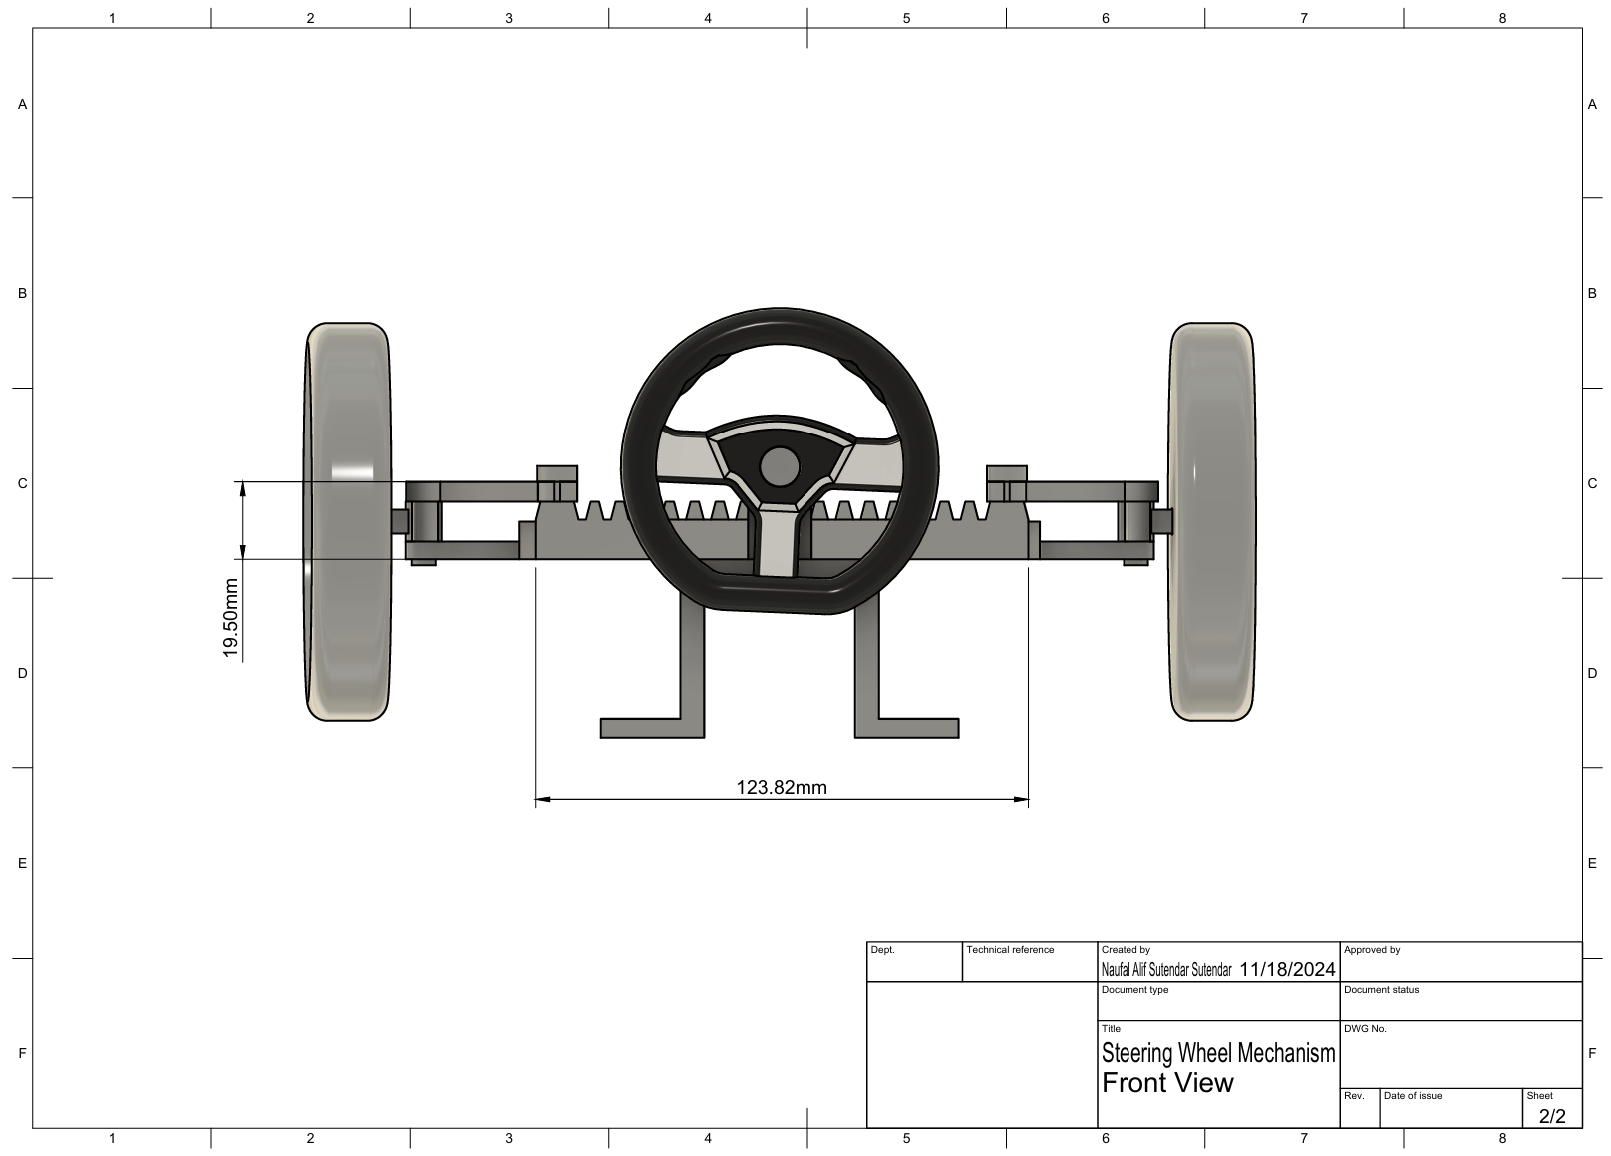

Figure 5 Front View

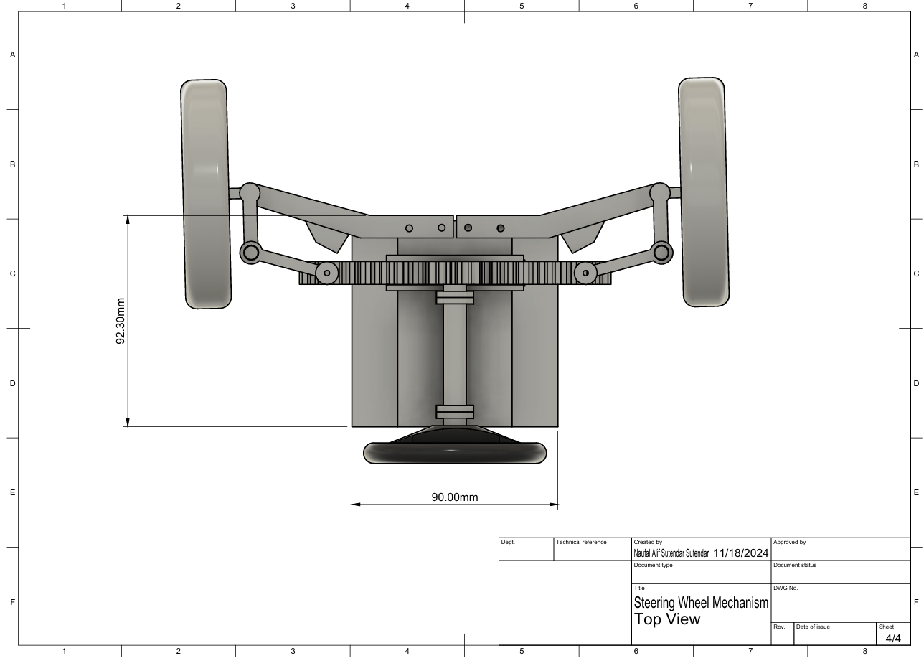

Figure 6 Top View

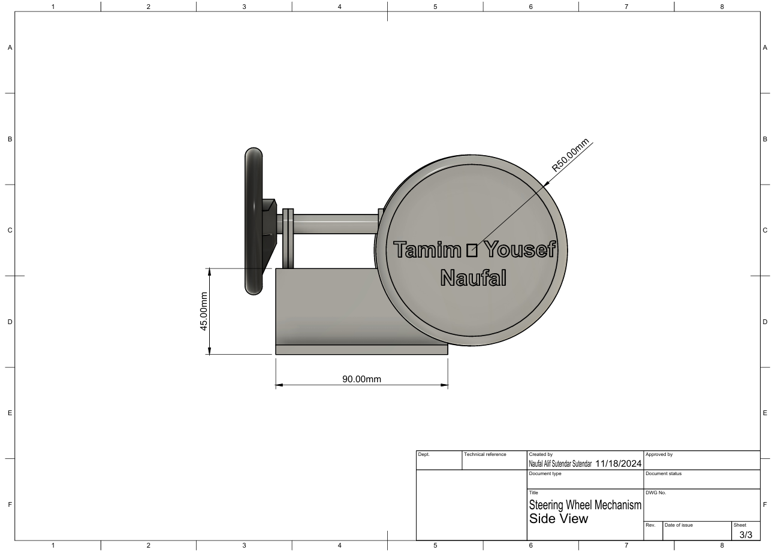

Figure 7 Side View

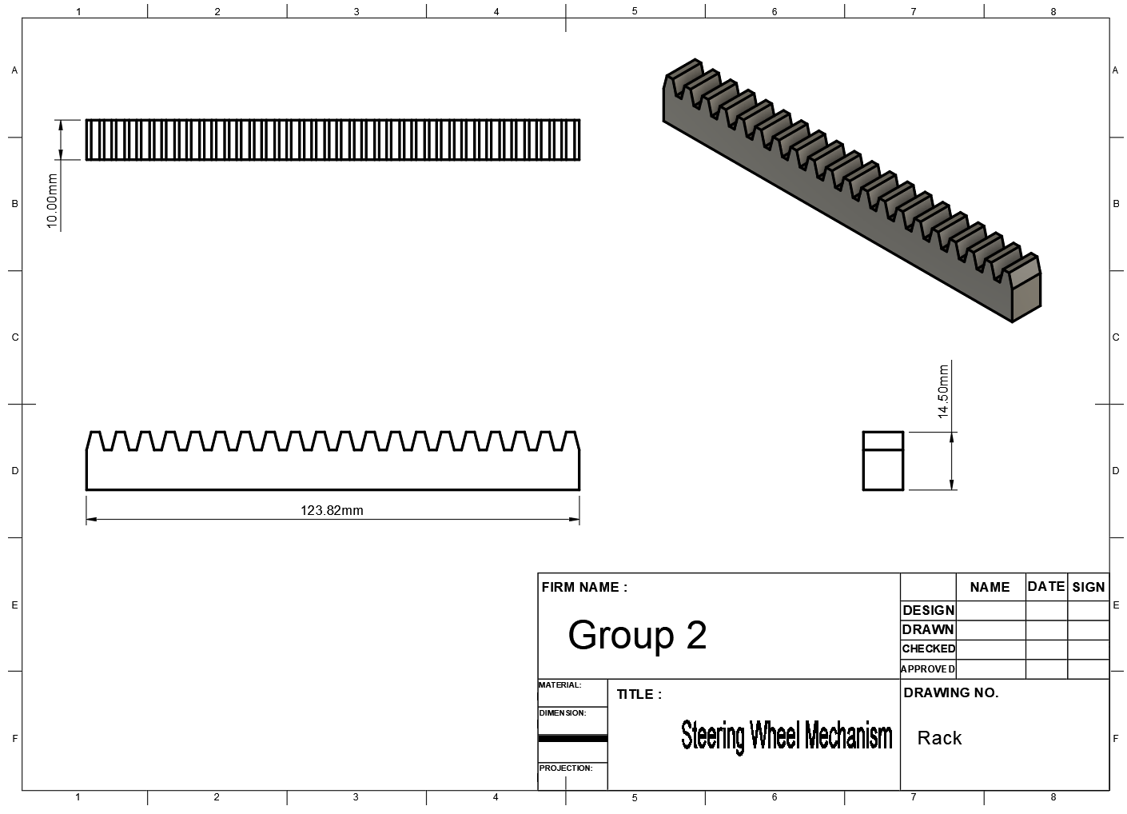

Figure 8 Rack of steering wheel mechanism

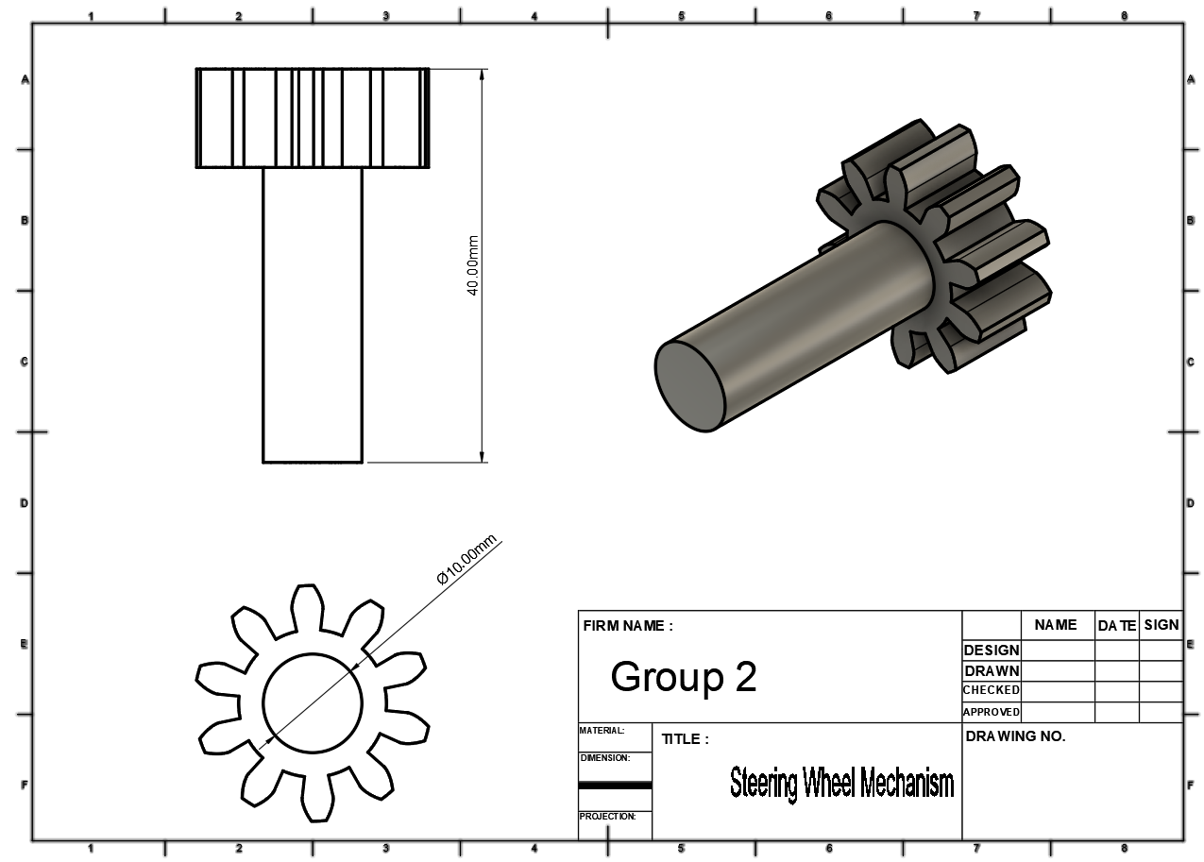

Figure 9 Gear and Shaft of steering wheel mechanism

# 

# **Chapter 4 : Design Specifications**

In Fusion 360, the use GF Gear Generator under the add-ons simplifies gear creation by eliminating the need for complex calculations and equations. The initial step is selecting the gear standard—either metric or imperial (English). Following this, specific parameters such as rack type, module, number of teeth, rack thickness, pressure angle, and height are chosen to define the gear’s characteristics. For this project, the gears have been customized with specifications detailed in the figure below, providing the necessary precision for a functional and responsive steering mechanism. This streamlined process in Fusion 360 ensures that the gears meet design requirements effectively and with minimal effort.



Figure 0 GF Gear Generator

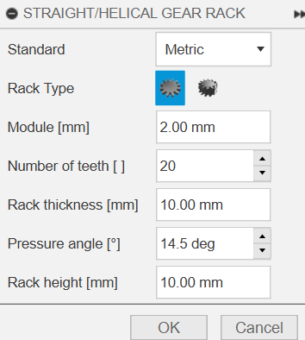

Figure 11 Specification of rack using GF Gear Generation

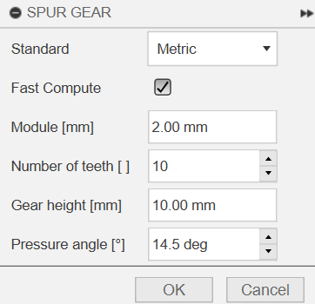

Figure 12 Specification of Pinion using GF Gear Generator

Note that all the gears should have the same module otherwise it will not attach to each other. For further experiment, pressure angle and number of teeth can be changed to satisfy the customer need like comfort, and less friction or other factor like material, and type of bearing.

Tolerance is the biggest constraint in this project. Simulation like motion study, or anything that is virtual is considered as ideal condition but when it comes to reality there must be an error. To avoid that, from author experience the mechanism needs to be designed to have tolerance less more than 0.3 mm or 75% of nozzle diameter in assumption that it will be manufactured using fused deposition modeling 3D printer with 0.4 mm MK8 all metal nozzle.

# **Chapter 5 : Manufacturability**

Fused Deposition Modeling abbreviated as FDM is a popular and easy to use additive manufacturing device that cover wide range of field. From farm to aerospace parts can be made with this game changer machine. It was invented by S. Scott Crump in 1988 with his wife Lisa Crump, co – founded the company Sratasys in 1989 to commercialize the FDM process. Nowadays, it is more likely to call as 3D printer without mentioning specific types of it. Absolutely there are advantages and disadvantages from this machine. The most prominent benefit is low – cost and ease to access. Moreover, what make it preferable is because one of the authors has it. Aside from that, this machine has tolerance and details problem. But it can be neglected by using our special features that have been mentioned in the previous part (Rack and Pinion Mechanism in Steering Wheel System). Furthermore, CNC Milling can be used to achieve more precise and accurate prototype for this project, but lack of access, budget, and time make it impossible to execute this project using this approach.

Polylactic Acid, abbreviated as PLA is a common, low - cost, and biodegradable (*figure 14)* material that will be used for this mechanism. Another reason is PLA does not need high – end manufacturing machine because it can be shaped in 180 – 220 degrees Celsius, low temperature. It also has rigid and stiff characteristic. Aside from all of those benefit, the only constraint of PLA is it can easily deform if it is exposed to heat above 60 degrees Celsius after couple of minutes. But since its does not need to works outdoor then this material is the best choices for this project.

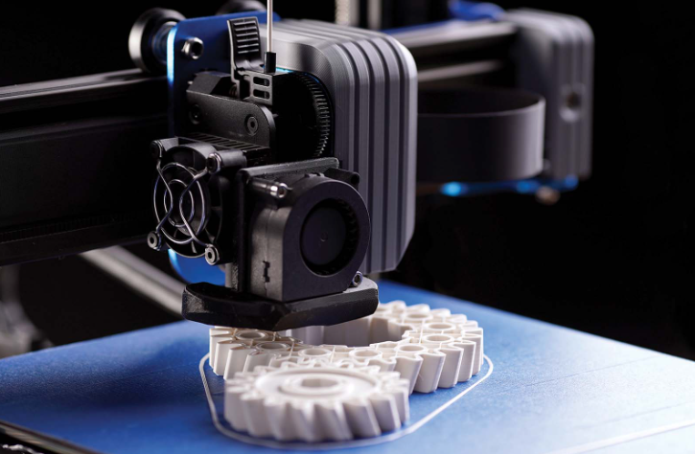

Figure 13 Fused Deposition Modeling Printer with PLA material source : [www.r3dprints.com](http://www.r3dprints.com)



Figure 14 PLA is biodegradable material source: www.shrinkfilmroll.com

Most of the PLAs have price between 70 – 200 SAR per kilogram with free shipping option but in this project, a PLA+ filament from CC3D were used as the printing material with price of 72 SAR per 1000 grams as shown in *figure 15*. It has suffix which is plus or max but PLA is PLA, it does not change the fact that it will always deform easily under the heat. Since it will only be use for demonstration, the PLA Is the most effective and efficient material.

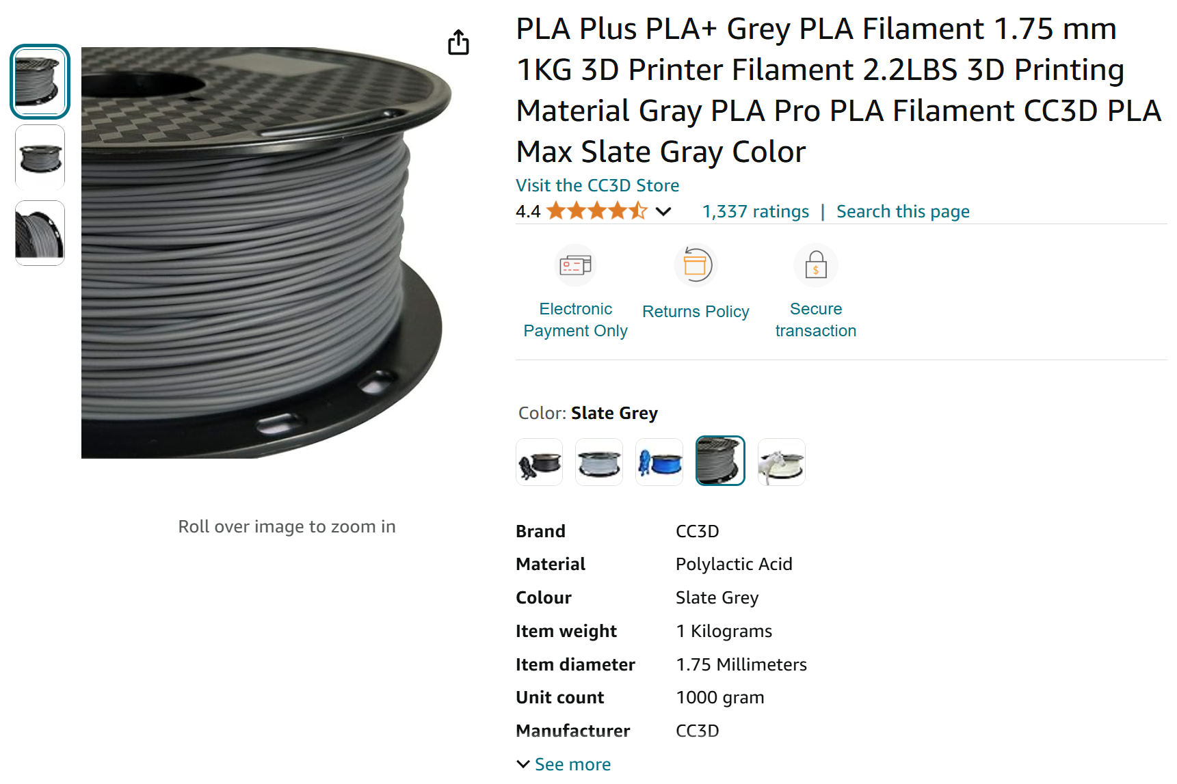

Figure 15 CC3D PLA+ Filament. Source : Amazon.sa

The printing time took almost 1 and half days and used approximately 300 grams of filament including the supports with 0.2 mm standard quality 20% infill and support structure. It has 275 layers and barely cover most of the build plate.

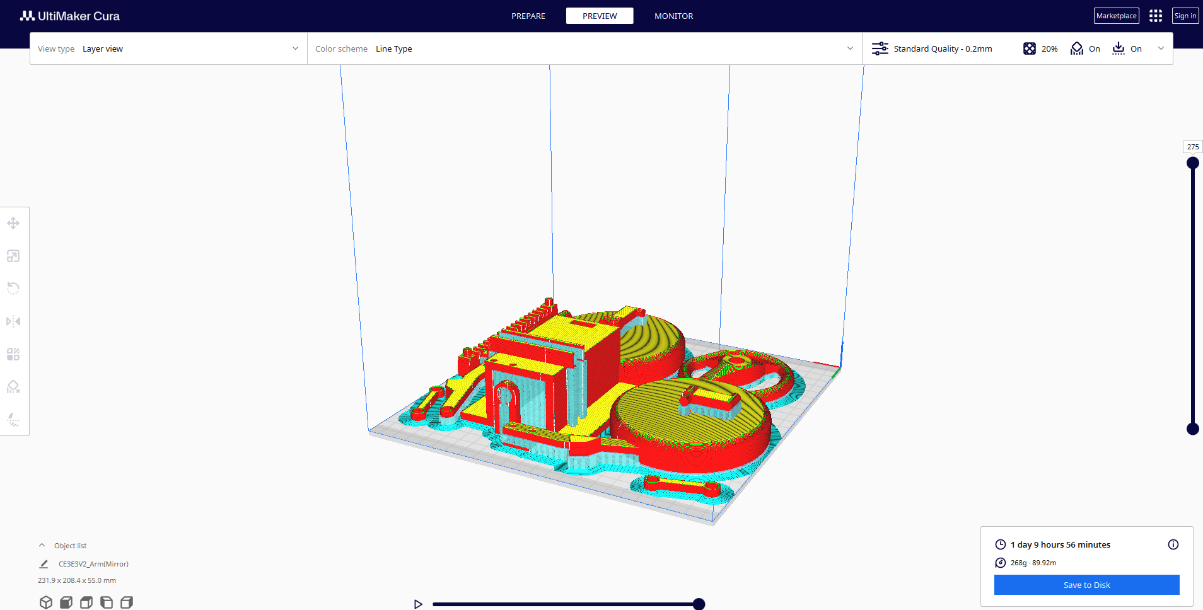

Figure 16 Estimated weights and time

|  |  |  |
| --- | --- | --- |
| **Total cost of the project** | | |
| **Activity** | **Price** | **Note** |
| Buying CC3D PLA Filament | 70 SAR | - |
| 3D printing service | 0 SAR | Using author’s machine |
| Total cost = 70 + 0 **= 70 SAR** | | |

It was printed successfully without any major trouble that will delay the process and assembled exactly the same as CAD design and motion study simulation. Here are the pictures of the fully assembled mechanism that will be demonstrated in order to fulfill the assignment theory of machine (figures below).

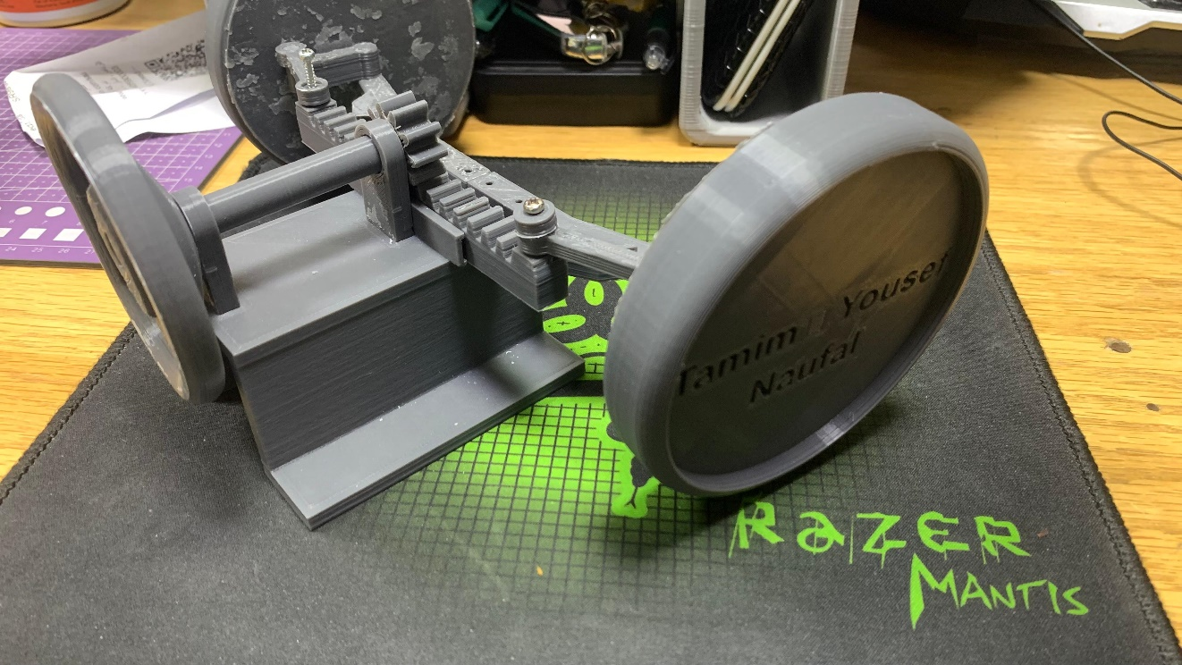

Figure 17 3D Printed mechanism view 1

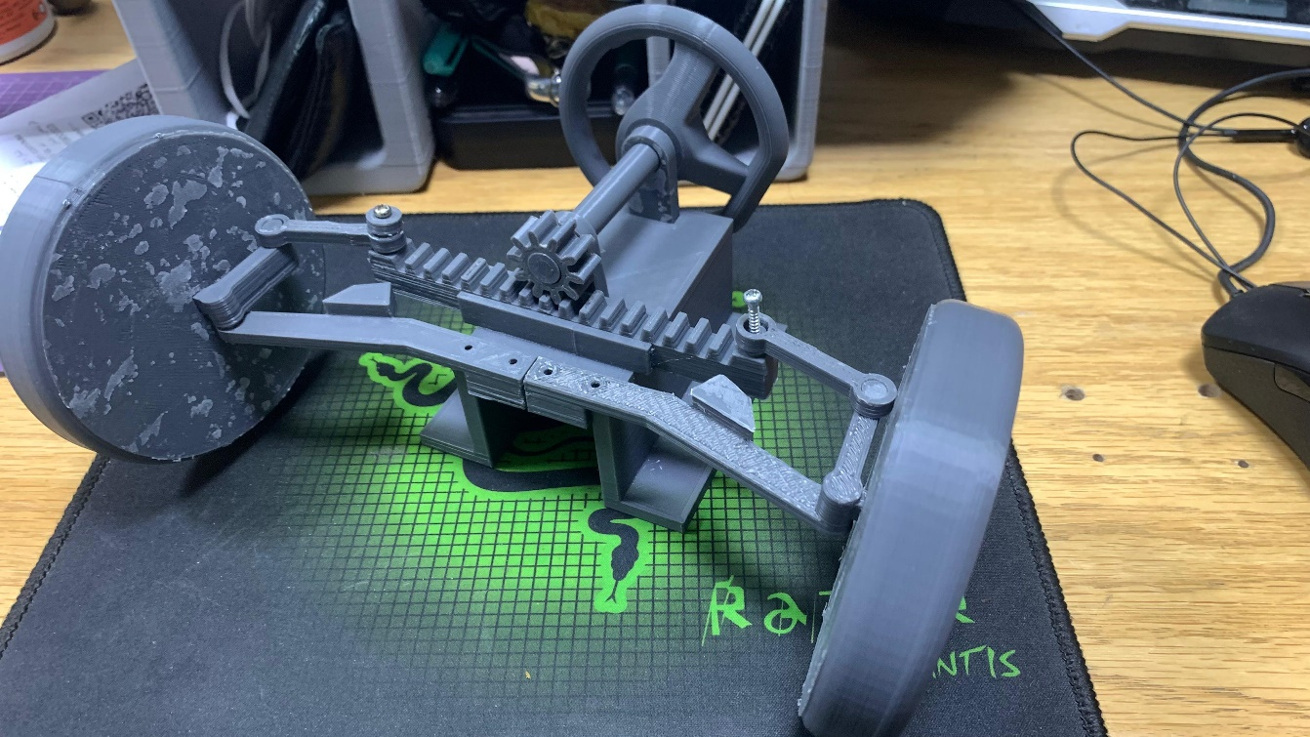

Figure 18 3D Printed Mechanism View 2

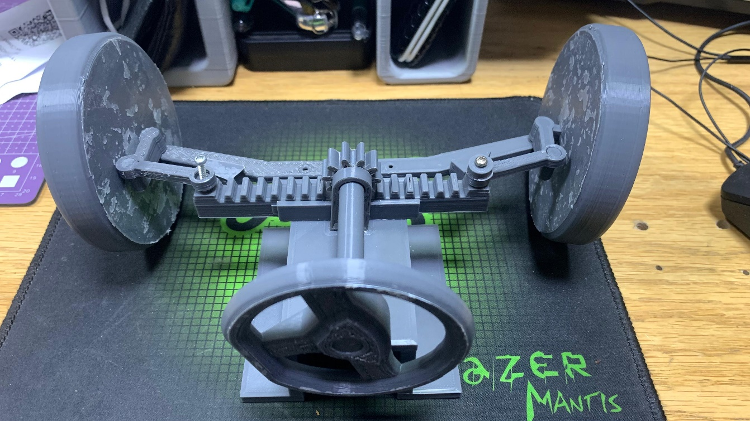

Figure 19 3D Printed Mechanism View 3

# **Chapter 6 : Conclusion**

This project presented a comprehensive analysis and development of a rack and pinion steering system, focusing on design optimization, material selection, and cost-effective manufacturability. By utilizing Polylactic Acid (PLA) as the primary material, this study explored sustainable manufacturing options, particularly within additive manufacturing, to produce lightweight and functional prototypes. The design process involved detailed specification and calculation to ensure that the rack and pinion system met structural and operational requirements, especially given the load-bearing and frictional stresses common in automotive applications.

The project encompassed a series of critical steps: design specification, precise calculation of gear parameters, 3D modeling, and prototype development using Fused Deposition Modeling (FDM) technology. These steps ensured an efficient and responsive steering mechanism, suitable for practical demonstration and experimental analysis. Detailed drawings and specifications enabled accurate production, while the manufacturability assessment highlighted the advantages and constraints of using PLA. Cost analysis further demonstrated that PLA-based 3D printing offers a budget-friendly alternative to traditional metal-based manufacturing, with the added benefit of reduced environmental impact.

In conclusion, this project demonstrated the feasibility of using 3D-printed PLA for functional steering mechanisms in scenarios where lightweight, sustainable materials are prioritized over extreme durability. Future improvements could include experimenting with alternative materials or PLA blends to improve structural integrity and longevity. The outcomes underscore the potential of additive manufacturing as a sustainable and flexible approach in engineering design, especially in prototyping and low-cost production of complex mechanical systems. This research contributes valuable insights for designers and engineers exploring environmentally friendly alternatives in the mechanical and automotive fields.

# **References**

1. Chopane, B. Gupta, A. Ajit, S. Kakroo, and A. Salvee, "Design and analysis of plastic gears in rack and pinion steering system for formula supra car," *Materials Today: Proceedings*, vol. 5, no. 2, pp. 5154–5164, 2018.
2. O. D. Suryavanshi, P. P. Sathe, and M. A. Takey, "Designing of the Rack and Pinion Gearbox for All Terrain Vehicle for the Competition Baja SAE India and Enduro Student India," *Int. J. Res. Eng. Technol.*, vol. 6, no. 9, pp. 14–19, Sept. 2017. [Online]. Available: <https://ijret.org/volumes/2017v06/i09/IJRET20170609014.pdf>.
3. R. Hanzaki, P. V. M. Rao, and S. K. Saha, "Kinematic and sensitivity analysis and optimization of planar rack-and-pinion steering linkages," *Mechanism and Machine Theory*, vol. 44, no. 1, pp. 42–56, 2008.
4. S. P. dos Santos, L. C. Brandão, L. H. Gallicchio, and Z. de C. Silveira, "Finishing process analysis between honing and hard hobbing in pinion gears applied to a steering system," *Energy Procedia*, vol. 14, pp. 2–8, 2011.
5. Arbor press works rack pinion used develop large forces, [Online]. Available: <https://www.chegg.com/homework-help/arbor-press-works-rack-pinion-used-develop-large-forces-requ-chapter-7-problem-2p-solution-9780471739326>.[Accessed:19-Oct 2024]
6. <https://www.ever-power.net/how-does-rack-and-pinion-steering-affect-overall-vehicle-weight/?amp=1>.[Accessed:29-Nov 2024]
7. [Amazon.sa Shopping Cart](https://www.amazon.sa/cart/add-to-cart/ref=dp_start-bbf_1_glance) .[Accessed:10-Nov 2024]

* **Schedule /Gantt Chart of project**

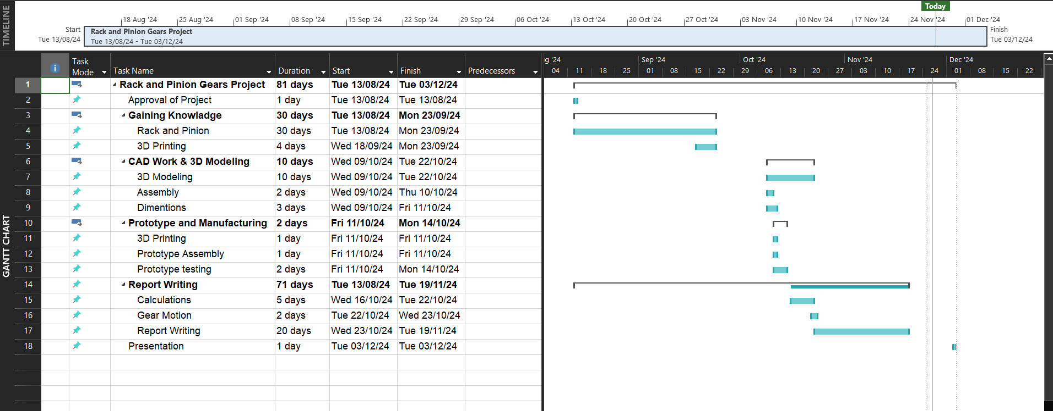

* **Detail role of Each Team Member**

|  |  |
| --- | --- |
| **Yusuf** | **Title page**  **Table of contents**  **Schedule /Gantt Chart**  **References** |
| **Tamim** | **Project Abstract**  **Introduction**  **Literature Review**  **Summary and Conclusions** |
| **Naufal** | **Design Specification**  **Design Calculations**  **Drawings with dimensions**  **Method of Solution/Manufacturability**  **Budget for Over Product Cost** |